2014 Health **&** Human Services Summit

Connecting Local Health & Human Service Organizations



**Training: 8:30 am to 2:15 pm**

**Vendors: 10:00 am to 2:00 pm**

**Poverty Simulation:**

**2:30 to 5:00 pm**

**October 03, 2014**

**8:00 a.m. to 5:00 p.m.**

**Daytona Beach Ocean Center**

**Event Hosted by:**

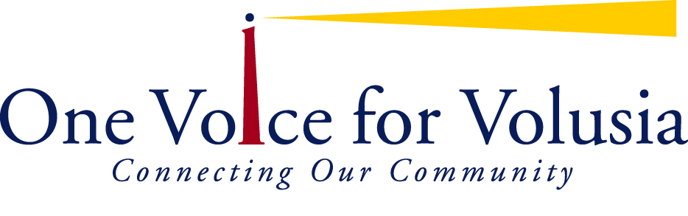

|  |  |  |  |  |  |
| --- | --- | --- | --- | --- | --- |
| 2014 Exhibitors  1 | Adoption and Family Support Center | 24 | Department of Health- Volusia County | 47 | Guardian Ad Litem Program |
| 2 | Advanced Practice Nursing Services | 25 | Department of Health-Volusia County | 48 | Florida United Methodist Children’s Home- Open Hearts Family |
| 3 | American Red Cross- Nurse Assistant Training Program | 26 | Florida Department of Health- Volusia County – Disease Control Unit | 49 | Children’s Home Society |
| 4 | Avenues 12 Women’s Recovery Houses | 27 | Health Planning Council | 50 | Florida KidCare and Volusia County Schools Social Services |
| 5 | Bethune-Cookman University | 28 | 51 | Community Partnership for Children |
| 6 | Camelot Community Care | 29 | Boys & Girls Clubs of Volusia/Flagler Counties | 52 | The Chiles Academy |
| 7 | COPE- Community Outreach to Prevent Eating Disorders | 30 | Department of Juvenile Justice | 53 | Palmer College of Chiropractic |
| 8 | Council on Aging of Volusia County | 31 | PACE Center for Girls | 54 | Presbyterian Counseling Center |
| 9 | Daytona Methadone Treatment Center | 32 | Goodwill Job Connection Center | 55 | Project Connect |
| 10 | Daytona State College | 33 | Healthy Families Florida | 56 | Stewart-Marchman-Act  Behavioral Healthcare |
| 11 | Devereux | 34 | The Healthy Start Coalition of Flagler and Volusia Counties- Community Café | 57 | Quantum’s Oceanside Recovery |
| 12 | Domestic Abuse Council | 35 | Infant Mental Health Chapter of Northeast Central Florida | 58 | The Salvation Army |
| 13 | Easter Seals | 36 | Halifax Urban Ministries | 59 | The ARC Volusia |
| 14 | 37 | Halifax Habitat for Humanity | 60 | VITAS Hospice |
| 15 | Early Learning Coalition of Flagler and Volusia | 38 | 61 | Stetson University |
| 16 | Career Source Flagler- Volusia | 39 | The House Next Door | 62 | The Daytona Beach News Journal |
| 17 | 40 | Junior League of Daytona Beach | 63 | The TEARS Foundation |
| 18 | Stewart- Marchman-Act  Beach House | 41 | Lifetree Café Daytona | 64 | United Healthcare |
| 19 | The Department of Children and Families | 42 | Mid Florida Community Services Head Start | 65 | United Way Volusia Flagler Inc. |
| 20 | Court Administration- Teen Court | 43 | North American Office Solutions | 66 | University of Florida Extension- Volusia County |
| 21 | Family Health Source Medical Centers- Northeast Florida Health Services | 44 | OVFV Professional Partners | 67 | The Visitation House |
| 22 | Family Renew | 45 | Circle of Friends Services | 68 | Florida Abolitionist |
| 23 | Good Samaritan Society Daytona Beach | 46 | North Carolina Outward Bound School | 69 | Healthy Communities |
| 70 | The Center for the Visually Impaired | 71 | disAbility Solutions | 72 | The Positive Champions Speakers Bureau |

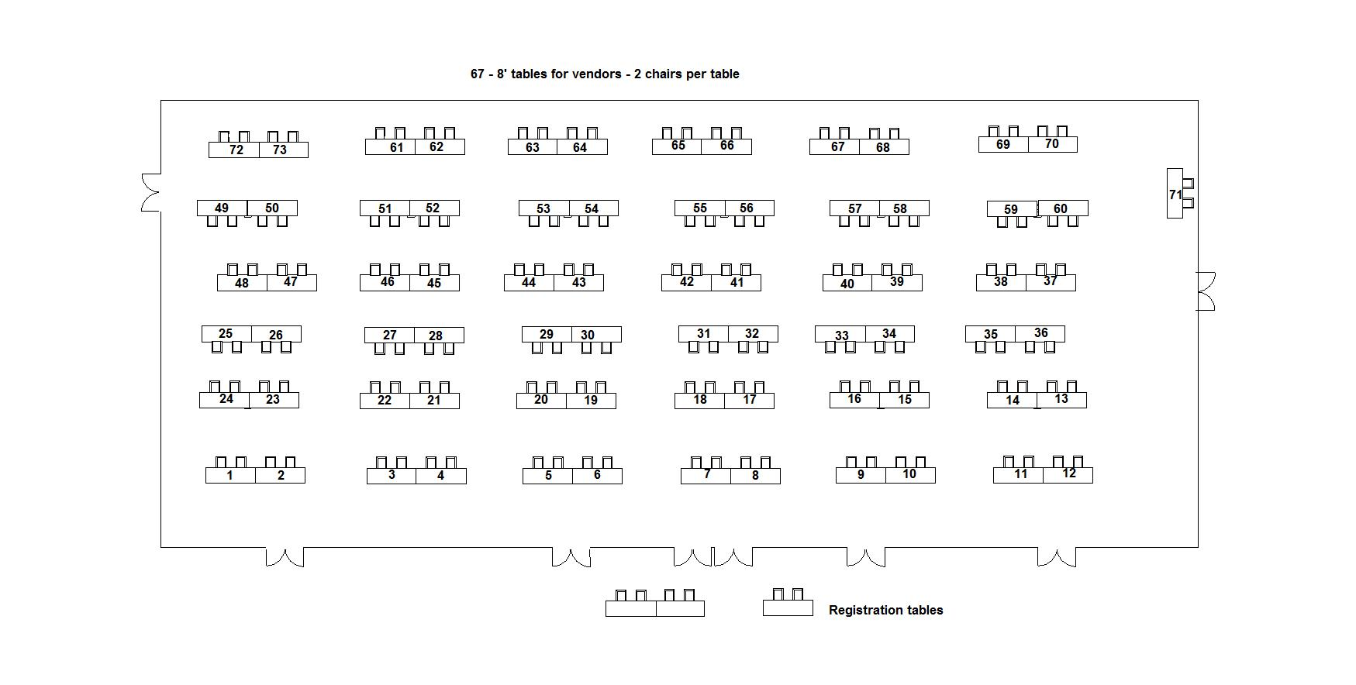

|  |  |
| --- | --- |
| logo**One Voice for Volusia** members come together with the common goal of improving the quality of life in Volusia County using the power of research, consensus building and collaboration in order to drive systemic social change. Our membership represents an organization of nonprofit leaders working in concert with businesses, government, and philanthropies to mobilize on the issues and initiatives that matter most to this community based on current data and best practice approaches. Come join the 105 (and counting) agencies, organizations, businesses and individuals who are dedicated to connecting our community to the highest quality health and human services available. We are proud to put on this summit each year. Visit [www.onevoiceforvolusia.org](http://www.onevoiceforvolusia.org) for more information.  **Come Join Us! Monthly Coalition Meetings:**  2nd Wednesday, 9 to 10:30 am  *1845 Holsonback Dr at the Volusia County Health Dept.* | **Description: cid:a786d5e9876c9c015325960ad9440b74The Community Connector** is an e-communication system designed to share important community information related to the social services field.  The system has been designed to benefit professionals working in the non-profit sector. There are currently over 2,700 members on the Community Connector send list.  **Sign up for this FREE service to receive information about:**   * Trainings * Special & fundraising events * New programs * Agency updates * Critical community issues   **Find out more or sign up here:**  <http://onevoiceforvolusia.org/community-connector/>  One Voice for Volusia Coalition Subscribers are able to send messages through this medium. |
| The Community Agenda initiative is a community engagement process to examine data and establish priorities to improve local health and human services in Flagler and Volusia Counties. The ninth annual *Community Agenda Snapshot* report is now available at [www.agendavf.org](http://www.agendavf.org). Printed copies will be available for $10 each.  tb5 art jpgThe **thrive by five Collaborative** is an initiative of the Community Agenda. Member organizations meet regularly to improve the early childhood system of care for prenatal through age five years and their families.  Please contact One Voice for Volusia at 386-947-8301 or visit the Community Agenda web site at [www.agendavf.org](http://www.agendavf.org) for additional details. | Did you know that in a given 30 day period, almost 90% of Volusia County youth ­reported that they **did not** use drugs or alcohol. Youth who feel that their community supports them are less likely to engage in substance abuse.  Let’s support and celebrate our youth who are participating in positive behaviors by providing them with safe, fun, environments and positive feedback. Join the youth substance prevention movement today by calling 386-947-8301 or emailing [michele@ovfv.org](mailto:michele@ovfv.org). |
| **Program Evaluation – Meeting Facilitation – Grant Writing Electronic Polling – Standards of Excellence – Marketing**  Did you know that One Voice for Volusia offers Professional Services at discounted rates for our members through our panel of vetted area experts? Call today: 386-947-8301. <http://onevoiceforvolusia.org/professional-services/> |
| **ReadingPals** is a joint project of United Way of Volusia-Flagler Counties and the Children’s Movement of Florida. This early literacy project is funded personally by Carol and Barney Barnett. Adult volunteers will work with children, pre-Kindergarten through first grade, to read books and enjoy literacy activities and discussions to increase the number of students reading at grade level by third grade. To volunteer, please call 386-366-9053 (Volusia) or 386-597-2950 (Flagler).**Reading Pals Logo_FINAL** | |



**Who Should**

**Attend?**

**Case managers**

**Counselors**

**Social workers**

**Therapists**

**Guidance counselors**

**Probation officers**

**Parents**

**Faith community**

**Law enforcement**

**Human service**

**Professionals**

**Who Should**

**Attend?**

**Case managers**

**Counselors**

**Social workers**

**Therapists**

**Guidance counselors**

**Probation officers**

**Parents**

**Faith community**

**Law enforcement**

**Human service**

**Professionals**