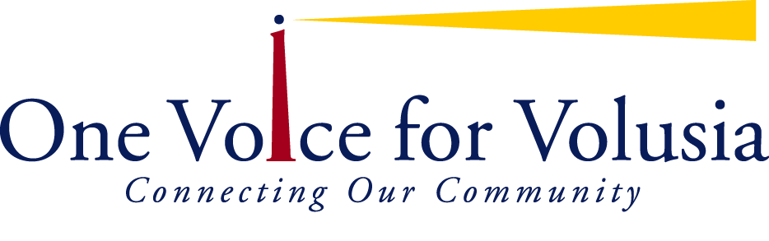
Corporate Level Subscription
2016-17 Subscriptions

Thank you for your support of One Voice for Volusia. To sustain the work and enjoy the benefits of One Voice for Volusia and its many initiatives in the community, the Board of Directors voted to institute an annual coalition subscription.

Please add my subscription good through June 30, 2017.
Main Contact Name & Title:
Agency:
Mailing Address, City, Zip:
Email:
Phone: |  | Cell: |  | Fax:
My Organization serves | - Youth |  | - Families |  | - Seniors | - Ages 0-5

Questions? Please call or email Julie Barrow at julie@ovfv.org or 386-947-8301
Additional Names, Titles and Emails of Staff who may also plan to attend:
Please Mark all that apply | - We enjoy meeting people and would like to help as we can with greeting new visitors and members.
Please Mark all that apply | - Please consider us as a resource! We have a specialty in:
Please Mark all that apply | - Our organization would be very interested in sponsorship opportunities
Please Mark all that apply | - Other:

______________________________________________________________________________________________________________________________________________________________________________________________________________________________________________________________________________________________________
Subscription Benefits: | Corporate  (Unlimited)  $300 | Corporate (Single Member)  $200
Any of your staff can attend monthly coalition meetings hosting over 85 community leaders for networking, distributing your literature, making announcements and obtaining resources | X
Submit your suggestions for Coalition meeting topics and speakers | X | X
Receive annual membership directory of over 150 agency and individual contacts (based on membership in August) | X | X
Receive Corporate Level recognition with your agency website linked on the new One Voice for Volusia website (5000 monthly hits) | X | X
Submit information to be sent out via the Community Connector (e- blast with 2900+ individual recipients who are eager to hear about your event or opportunity) | X | X
Receive Community Connector messages | X | X
Receive discounts at OVFV events and functions and have first option to sponsor events at member rates | X | X

